**Server-Intro-Man-Pages**

**ubuntu@ip-172-31-10-134:~$ man man**

A logical place to learn more about the manual system is the man page for man.

**man man**

We see the standard breakdown of a man page, with NAME, SYNOPSIS, DESCRIPTION, and OPTIONS. There is also an OVERVIEW, and DEFAULTS section for man’s man page.

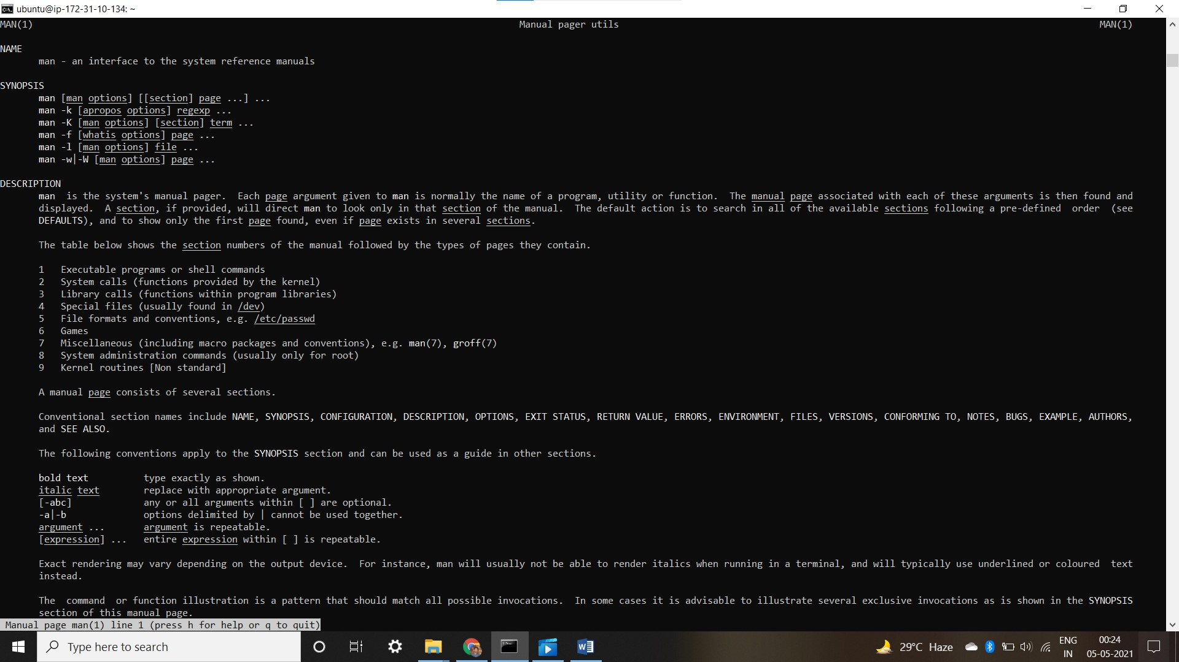

**ubuntu@ip-172-31-10-134:~$ man -a passwd**

**--Man-- next: passwd(1ssl) [ view (return) | skip (Ctrl-D) | quit (Ctrl-C) ]--Man-- next: passwd(1ssl) [ view (return) | skip (Ctrl-D) | quit (Ctrl-C) ]**

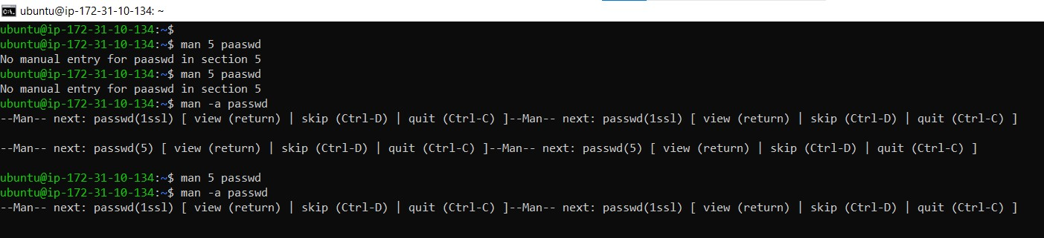

**ubuntu@ip-172-31-10-134:~$** man -a passwd

--Man-- next: passwd(1ssl) [ view (return) | skip (Ctrl-D) | **quit (Ctrl-C**) ]--Man-- next: passwd(1ssl) [ view (return) | skip (Ctrl-D) | **quit (Ctrl-C) ]**

(Please enter again)

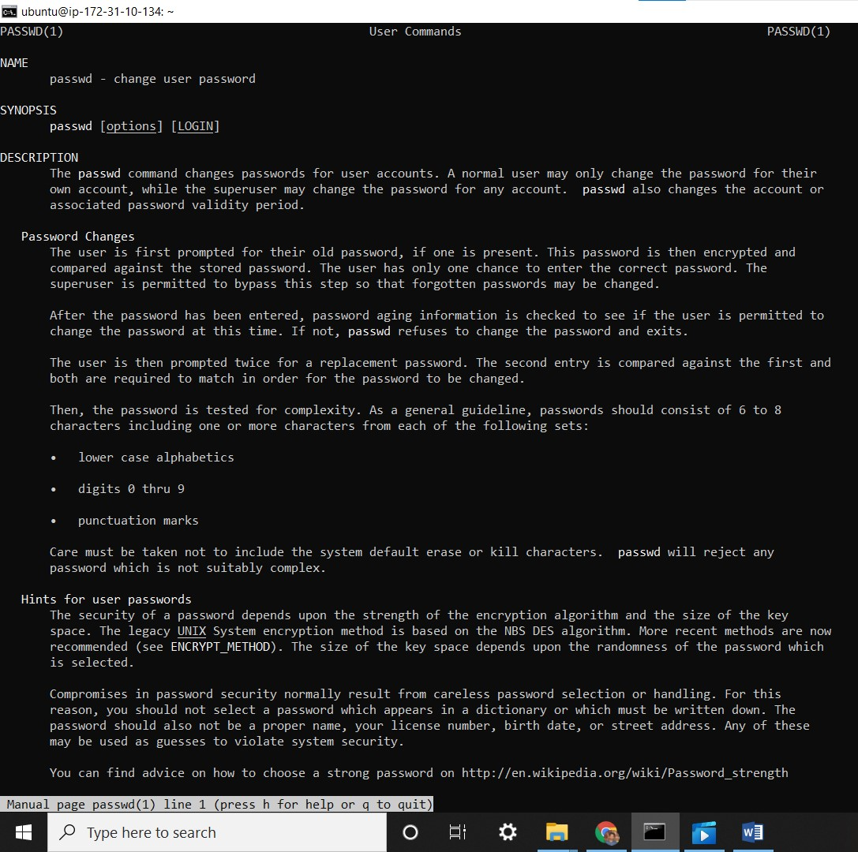

--Man-- next: passwd(5) [ view (return) | skip (Ctrl-D) | quit (Ctrl-C) ]--Man-- next: passwd(5) [ view (return) | skip (Ctrl-D) | quit (Ctrl-C) ]

ubuntu@ip-172-31-10-134:~$ **man 5 passwd**

ubuntu@ip-172-31-10-134:~$ **man -a passwd**

--Man-- next: passwd(1ssl) [ view (return) | skip (Ctrl-D) | quit (Ctrl-C) ]--Man-- next: passwd(1ssl) [ view (return) | skip (Ctrl-D) | quit (Ctrl-C) ]

ubuntu@ip-172-31-10-134:~$ man -k pass

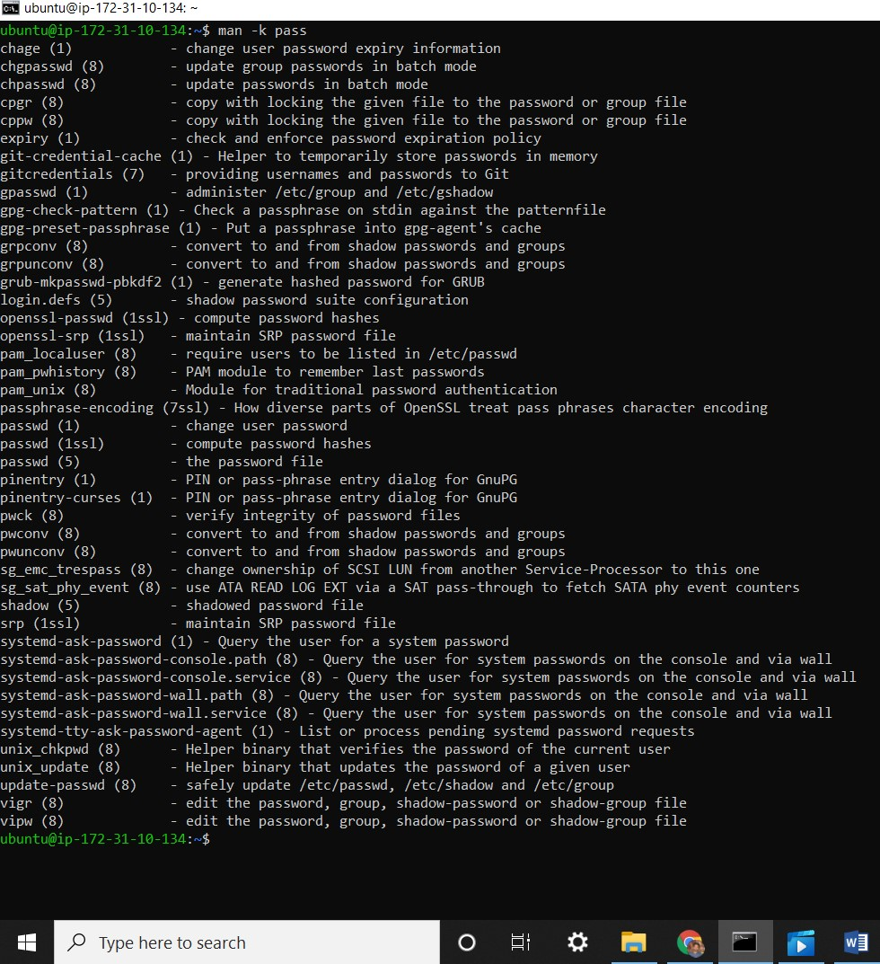

**ubuntu@ip-172-31-10-134:~$ man -k passwd**

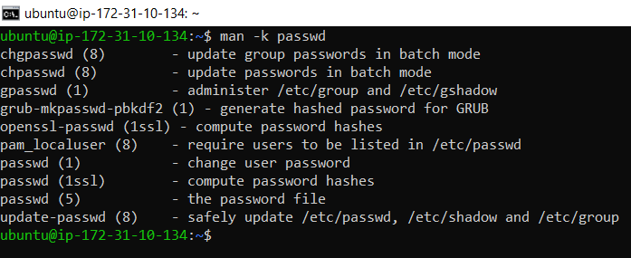

**ubuntu@ip-172-31-10-134:~$ man -k group**

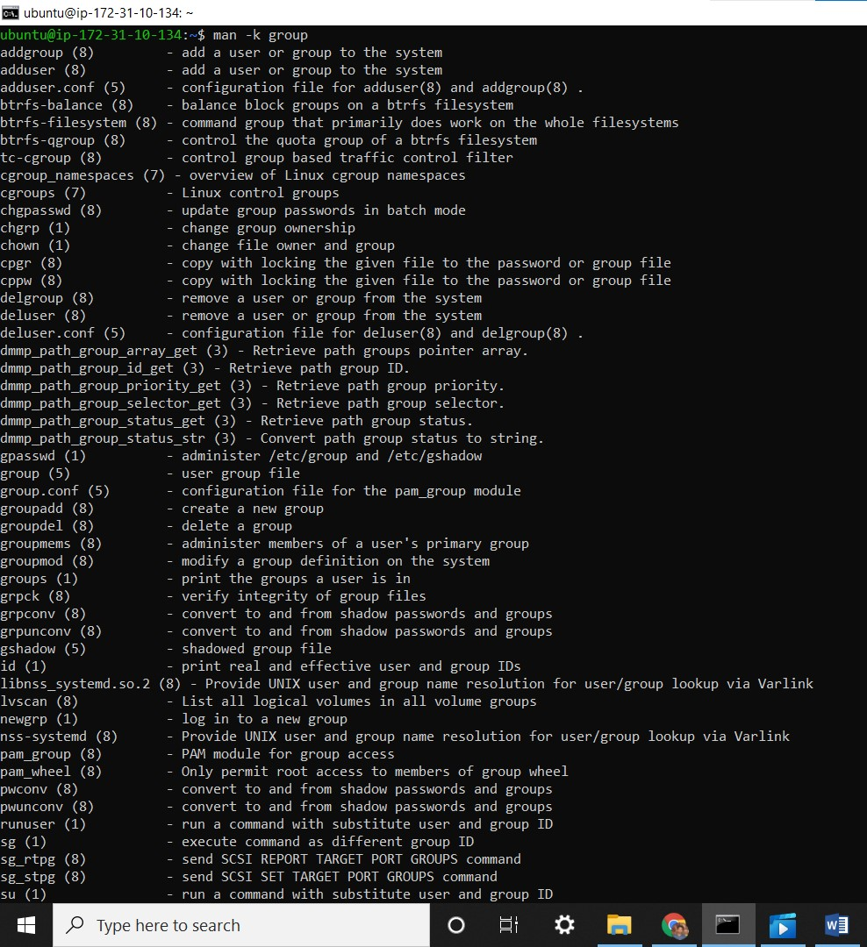

**ubuntu@ip-172-31-10-134:~$ man ls**

